**Under the Guidance of**



**SIDDHARTH**

**INSTITUTE OF ENGINEERING & TECHNOLOGY: PUTTUR**

**(**

**AUTONOMOUS**

**)**

**DEPARTMENT**

**OF**

**CIVIL**

**ENGINEERING**

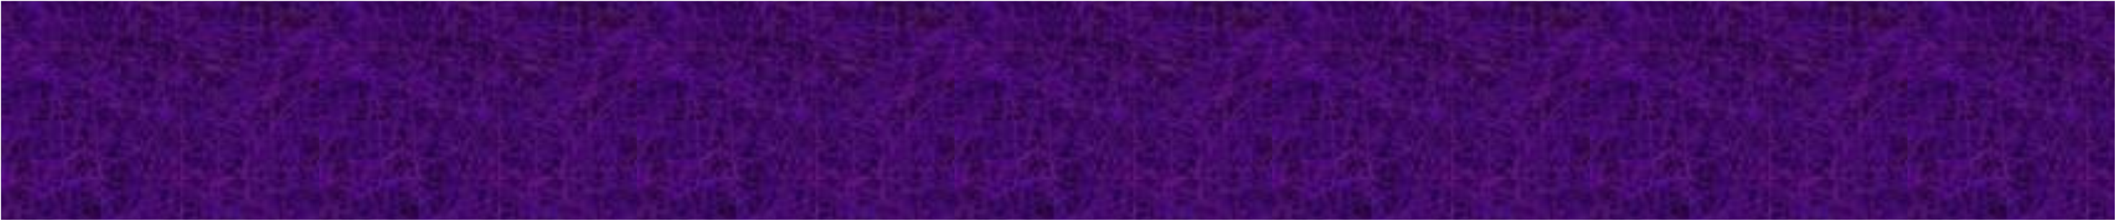

**DESIGN OF TRAFFIC SIGNAL AT PUTTUR**

**JUNCTION WITH ARTIFICIAL INTELLIGENCE**



**Mr.S.Venkataraman Asst. Prof.**

# Department of civil

**N. Kalpana 21F65A0119**

1. **Rajesh 21F65A0131**
2. **Madhu 21F65A0123**

**K. Bhargav 21F65A0108**

# CONTENTS

* Introduction of Traffic Design
* Literature review
* Abstract
* Data Collection
* Design calculation
* References

2

* Traffic signals are essential part of managing traffic during congestion.
* It provides clear instruction to drivers and ensure smooth traffic flow.
* Traffic signals are devices positioned at road intersections and pedestrian crossing to control the traffic flow.

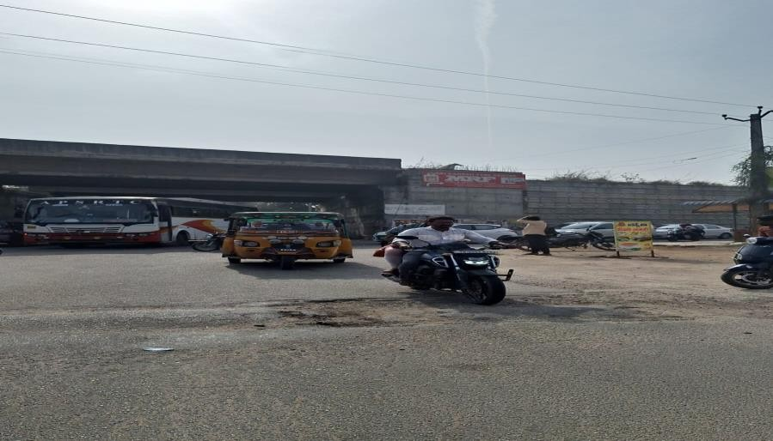

## INTRODUCTION

* 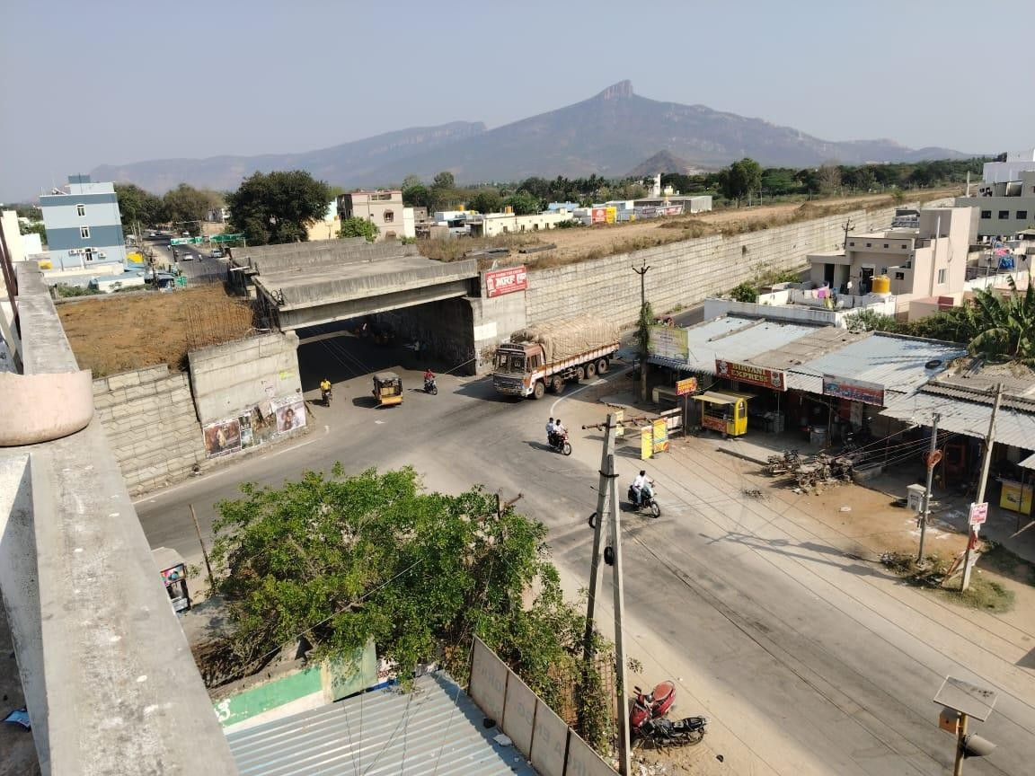Timing constraints
* Traffic volume constraints
* Pedestrain safety
* Efficiency
* Prevent accidents
* Minimize congestion
* Control flow of traffic

### LITERATURE REVIEW

* TITLE:- Optimization of Smart Traffic Governance System Using Artificial Intelligence.
* AUTHOR/YEAR:- Aayush Sukhadia, Khush Upadhyay, Megasree Gundeti, Smit Shan/2020
* STUDY:- It optimizes traffic flow, predicts congestion, adapts signal control, optimizes routes and facilitates data-driven decision making. ➢ TITLE:-Implementation of AI in Traffic Management.
* AUTHOR/YEAR:-S.Faiza Nasim, Asma Qaiser/2023
* STUDY:-These include challenges, Data Quality issues, Computational complexity and integration with existing infrastructure.

**LITERATURE REVIEW**

* TITLE:-Implementing AI-Driven Traffic Signal System for Enhanced Traffic Management in Dammam
* AUTHOR/YEAR:-Khalid Mohammed Almatar/2024
* STUDY:-AI-Driven traffic singal system, traffic management, Dammam, machine learning, predictive analytics, congestion mitigation .
* TITLE:-Smart Traffic Light System by using Artifical Intelligence
* AUTHOR/YEAR:-Syed Saood, Muhammad Naseem, Idris Mala/2019
* STUDY:-Explore the integration of AI algorithms into traffic signal control to dynamically adjust timing based on real time traffic condition.

### LITERATURE REVIEW

* TITLE:- Artificial intelligence for traffic signal control based solely on video images.
* AUTHOR/YEAR:- Hyunjeong Jeon, Jincheol Lee, Keemin Sohn /2018.
* STUDY:- The system likely employs computer vision techniques to analyze traffic patterns and adjust signal timings in real-time, aiming to optimize traffic flow and reduce congestion.

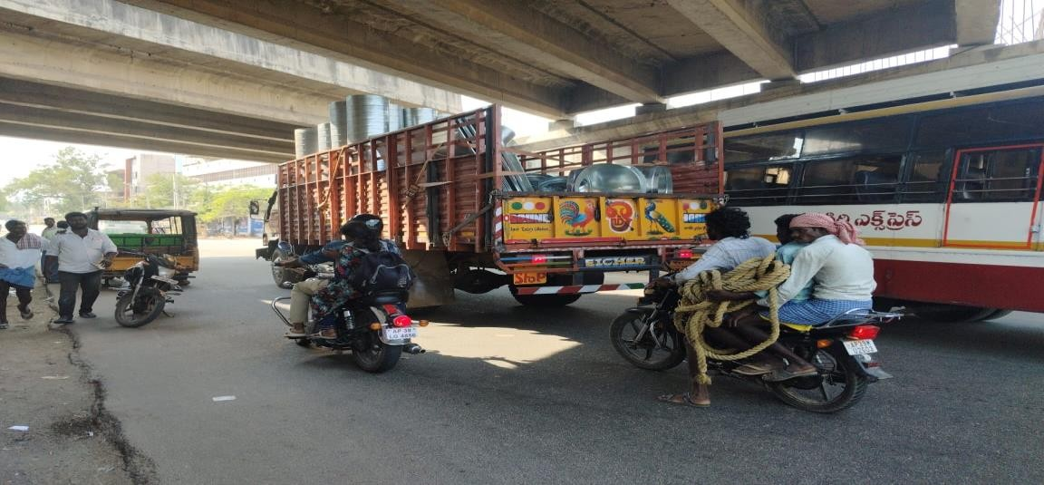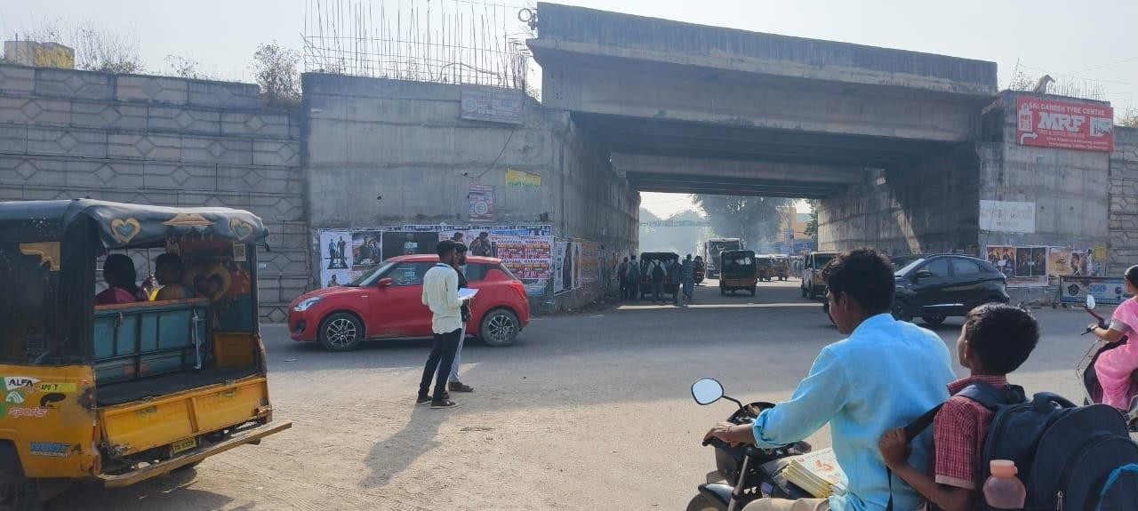

#### ABSTRACT

Puttur is our area of concern for traffic jams. If Congestion in Puttur can be reduced it will ultimately reduce the travelling to all nearby places.

* Analysed the whole Area
* Found out the main causes for the congestion
* Put up some Remedial Measures to Reduce congestion
* Designed Traffic signal using webstar method

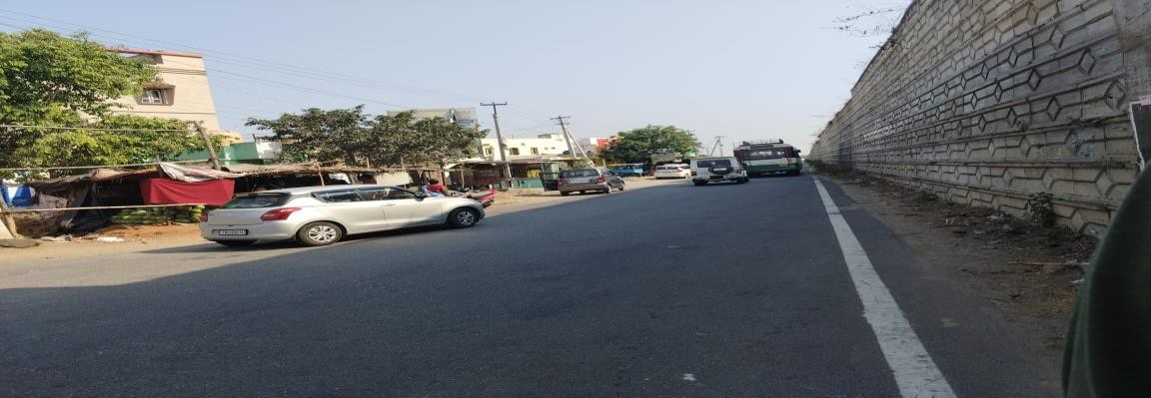

**DESIGN OF TRAFFIC SIGNAL USING WEBSTAR METHOD**

❑ In this method ,the total cycle of the signal is determined which forms a total least delay occurring at signal .

##### FORMULA FOR CYCLE TIME ;

Co =1.5𝐿+5

1−𝑌

Y= Normal Flow /Saturated Traffic Flow

Y= qi/Si

Green Time = Y1/Y*(Co-L)

#### DATA COLLECTION

▪ The PCU value of a particular vechicle class may be considered as the ratio of capacity of a roadway when there are passenger cars only to the capacity of the same roadway when there are vehicle of that class only.

PCU Values recommended by IRC

|  |  |  |
| --- | --- | --- |
| **SERIAL NO** | **VEHICLE TYPE** | **EQUIVALENT PCU FACTOR** |
| 1 | BUS/TRUCK | 2.2 |
| 2 | TRACTOR TROLLY | 4.0 |
| 3 | GRAMIN SEWA/PICKUP VAN CAR | 1 |
| 4 | TWO WHEELER | 0.5 |
| 5 | E-RICKSHAW/AUTO RICKSHAW | 1.5 |

### SATURATED TRAFFIC FLOW [Si]

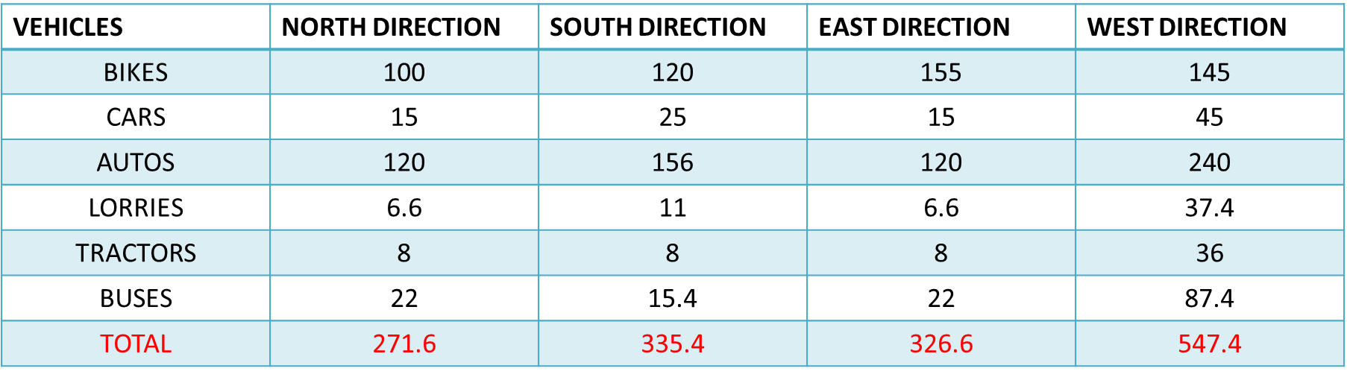

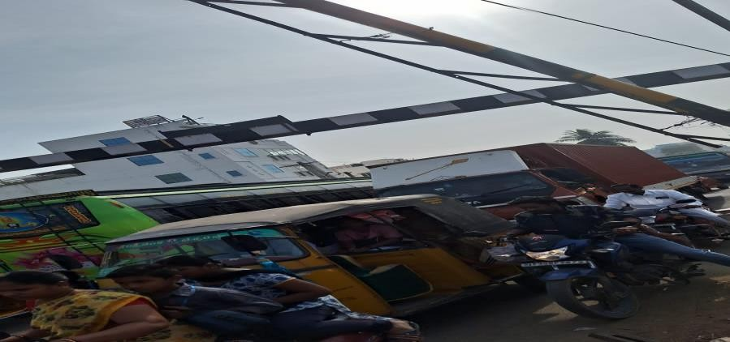L=2N+R

N=NUMBER OF PHASES

R=ALL RED TIME

L=2*4+60=68Sec

#### NORMAL FLOW [qi]

|  |  |  |  |  |
| --- | --- | --- | --- | --- |
| **VEHICLES** | **NORTH DIRECTION** | **SOUTH DIRECTION** | **EAST DIRECTION** | **WEST DIRECTION** |
| BIKES | 25 | 30 | 27.5 | 50 |
| CARS | 15 | 44 | 37 | 40 |
| AUTOES | 36 | 25.2 | 22.8 | 42 |
| LORRIES | 4.4 | 8.8 | 6.6 | 24.2 |
| TRACTOR | 4 | 4 | 4 | 4 |
| BUSES | 6.6 | 8.8 | 6.6 | 13.2 |
| TOTAL | 91 | 120.8 | 104.5 | 173.4 |

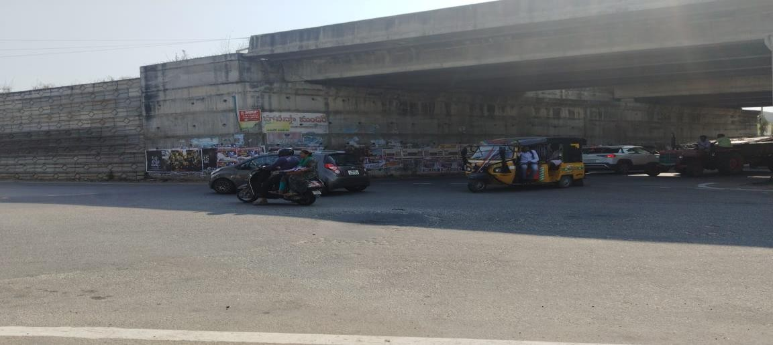 Y=σ (𝑞𝑖)

𝑠𝑖

Si=saturated traffic flow (or) volume qi=normal flow (or) traffic volume

##### **DESIGN CALCULATION**

* Y= qi/Si
* Example = 91/271.6 = 0.33
* Total Y = Y1+Y2+Y3+Y4
* CYCLE TIME = 1.5* L+5/1-Y

Example = 1.5*68+5/1-0.33 = 159.70 sec

* GREEN TIME = Y1/Y *(C0-L)
* Example = 0.33/0.31 *(159.70-68) = 23.1 sec

|  |  |  |  |  |  |
| --- | --- | --- | --- | --- | --- |
| **VEHICAL DIRECTION** | **NORMAL**  **FLOW**  **(qi)** | **SATURATED**  **FLOW**  **(Si)** | **Y=(qi/Si)** | **CYCLE TIME Co=1.5L+5/1-Y** | **GREEN TIME**  **G=**𝒀𝟏**(Co-L)**  𝒀 |
| North | 91 | 271.6 | 0.33 | 159.70 | 23.1 |
| South | 120.8 | 335.4 | 0.36 | 167.18 | 27.25 |
| East | 104.5 | 326.6 | 0.31 | 155.07 | 20.60 |
| West | 173.4 | 547.4 | 0.31 | 155.07 | 20.60 |
| TOTAL | 489.7 | 1481.2 | 1.31 | 637.02 | 91.55 |

Data Analysis

Buses Tractor

31

%

22

%

19

%

10

%

14

%

4

%

bikes

cars

Auto

lorry

###### Check:-

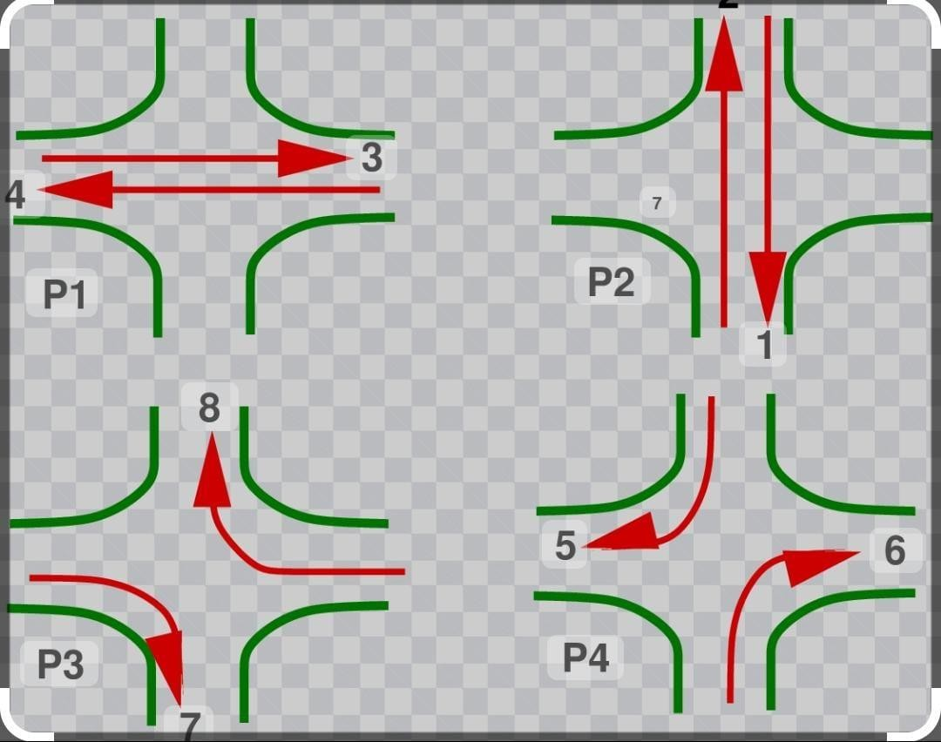Effective green time = Lost time per cycle

G = L

Considering the phase 4

L = 68 Sec

G = G2+G3+G4

= 27.2+20.6+20.60

= 68Sec

G = L

68Sec = 68Sec

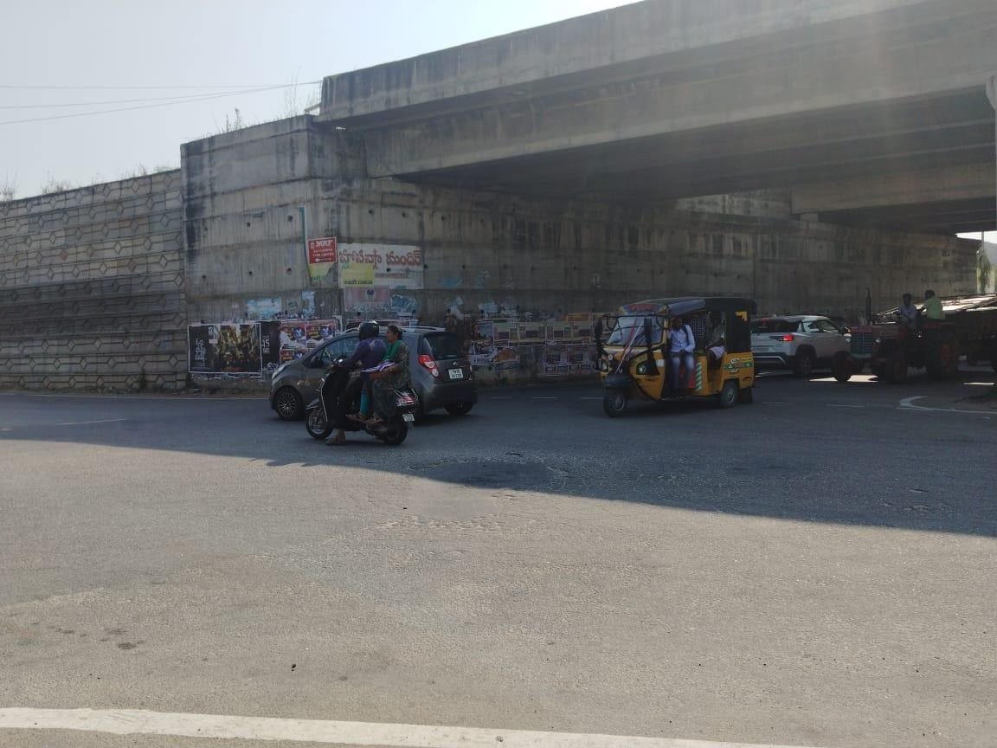

##### **REFERENCES**

* Prathamesh pavaskar , Aditya Narsule , and Dr. Aniket V.Khandagale. “Smart Traffic Management using deep learning and Raspberry pi.” International journal of engineering research and technology (IJERT), vol.8,no.11,2019 .
* S.A.Adegoke and I.S.Akande. “Design of an intelligent traffic control system using artificial intelligence.” International journal of computer applications, vol.91,no.9,2014 .
* C.J. Sun and R.M. Kriegel. “Dynamic traffic signal control using fuzzy logic.” Transportation research part C: Emerging technologies, vol.5,no.5,1997 .
* S.L. Smith, K. Schindler, K. Wagner, and M.L. Delle Monache. “Adaptive traffic signal control with neural networks and deep reinforcement learning.” Transportation research part C: Emerging technologies, vol.111,2020 .
* H.Isele, S.Sivakumar, and M.Trivedi. “ Traffic signal control using deep reinforcement learning.” IEEE Intelligent transportation systems conference, 2017 .
* J.A.Harston, S.M.Lavalle, and J.A. Fernandez. “Intelligent traffic signal control using model free deep reinforcement learning.” IEEE

Transactions on intelligent transportation systems, vol.22,no.8,2021 .

* Syed saood zia, Muhammad Naseem, Idris Mala. “ Smart traffic light system by using artificial intelligence .” By the adaptive year of 2019 .
* Hyunjeong jeon, Jincheol lee, and Keemin sohn .” Artificial intelligence for traffic signal control based slolely on video images .” By the adaptive year of 2017 .
* “Adaptive traffic signal control with deep reinforcement learning.” By the Shaobo cui , at the year of 2020 .



